SUCCEED teacher workshop 2013

Bathtub Analogy – Discussion

In the bathtub analogy, explain what is represented by each of the following:

Greenhouse Gas Analogy | Energy Analogy
- The bathtub
The atmosphere | The Earth and its atmosphere
- The water
Greenhouse gases (e.g., carbon dioxide) | Energy or power
- The flow rate of water entering the bathtub (faucet)
The emission rate of greenhouse gases entering the atmosphere | The incoming radiation
- The flow rate of water leaving the bathtub (drain)
The rate at which greenhouse gases leaves the atmosphere through sinks (absorption by ocean, uptake in forests, etc) | The outgoing radiation
- Clogging of bathtub drain
Changes in the ability of sinks to absorb greenhouse gases from the atmosphere | Greenhouse gases in the atmosphere
- The level of water in the bathtub
The total mass of greenhouse gases in the atmosphere | Amount of energy stored by Earth and its atmosphere
- The change in the flow rate of water leaving the bathtub
The change in the rate at which greenhouse gases leaves the atmosphere | Change in the amount of outgoing radiation
- The underlying cause of the change in the flow rate of water leaving the bathtub
The underlying cause of the rate at which water leaves the bathtub is the pressure in and on the water. As the water level in the tub gets higher, the pressure increases and hence the rate of water flow out of the tub increases. Something similar is true for a greenhouse gas like CO₂. Thus the increasing mass of CO₂ in the atmosphere will cause the rate of CO2 leaving the atmosphere to increase, until it exactly balances the rate of CO₂ entering the atmosphere. At this point, the system is in equilibrium, and the amount of CO2 in the atmosphere will be constant henceforth as long as there are no changes in inputs or outputs or other causal factors. | In the simplest case, we can imagine that increasing CO₂ greenhouse gases is essentially like placing a screen with small openings over the bathtub drain. This slows down the water (radiation) exiting the tub (the Earth and its atmosphere). We need more pressure to force the water through the screen so that the exiting water flow rate equals the entering water flow rate. The water level in the tub rises, providing the extra pressure needed to achieve equilibrium between incoming and outgoing water flow (i.e., radiation flow).
- Water spilling over the side of the bathtub
The Earth becomes uninhabitable as we know it. This may lead to a runaway greenhouse gas effect where the Earth enters a new equilibrium state and, due to hysteresis, cannot easily return to what we know as normal. | The Earth becomes uninhabitable as we know it. This may lead to a runaway greenhouse gas effect where the Earth enters a new equilibrium state and, due to hysteresis, cannot easily return to what we know as normal.

Exercises Greenhouse Gas Analogy

- Assume that the mass of carbon dioxide equivalent (CO_{2e}) entering the atmosphere continues indefinitely at the current levels of 7 GT of CO_{2e}/year. Show this flat rate on the graph below. Now draw another flow rate curve for CO_{2e} leaving the atmosphere versus time. Show how it will reach a dynamic equilibrium. Indicate on the time-axis the amount of years that will take (100, 1,000, 10,000, even more?)

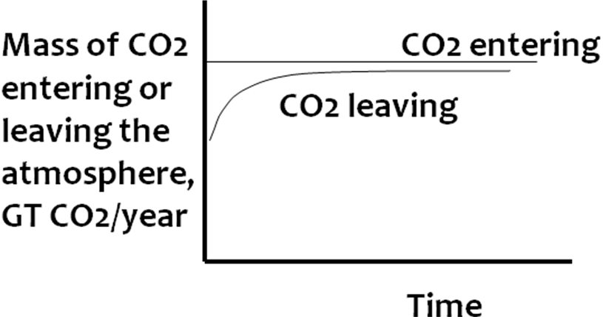

- Consider the total mass of CO_{2e} in the atmosphere at any given time. Draw a curve showing this total mass versus time based on the curves you drew in the previous exercise.

